SIMATS ENGINEERING

ASSESSMENT TOOL 2

G.CHAKRADHAR
192311439

COURSE NAME: Database Management Systems COURSE CODE: CSA05
QUESTIONS Total Marks: 50
Q.No | Question | Bloom's Level | Marks
1 | Construct a concept map linking the following terms: DBMS, Schema, Instance, Data Model, ER Diagram, Entity, Attribute, Relationship. | BL2 – Understand | 5
2 | Create a concept map for the three-level ANSI/SPARC architecture showing data independence at each level. | BL2 – Understand | 5
3 | Map the relationship between file-based systems and database systems, highlighting the problems solved by DBMS. | BL2 – Understand | 5
4 | Design a concept map for ER diagram components: entity, weak entity, attribute types, relationship types, and participation constraints. | BL2 – Understand | 5
5 | Construct a concept map comparing Hierarchical, Network, and Relational data models with their key properties. | BL2 – Understand | 5
6 | Develop a concept map for the EER model showing how it extends the basic ER model with generalization, specialization, and aggregation. | BL2 – Understand | 5
7 | Create a visual concept map for the DBMS software architecture, illustrating the flow from user request to data retrieval. | BL2 – Understand | 5

8 | Map the data models discussed in CO1 to real-world applications and explain the suitability of each model. | BL2 – Understand | 5
9 | Construct a concept map for schemas and instances, showing how they relate to physical and logical data independence. | BL2 – Understand | 5
10 | Design a concept map for the roles and responsibilities in a DBMS environment: DBA, End User, Application Developer. | BL1 – Remember | 5
Code of Conduct:

I G.CHAKRADHAR (192311439) certify that this submission is my original work and that I have adhered to the guidelines specified for this assessment. I understand that any violation of academic integrity rules will result in disciplinary action.

Signature of the student:
G.CHAKRADHAR

1.DBMS, Schema, Instance, Data Model, ER Diagram, Entity, Attribute, Relationship.

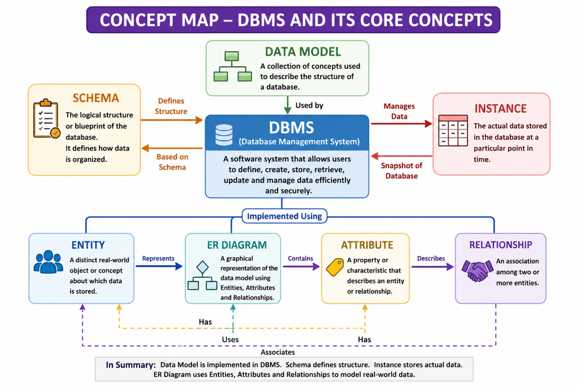

- DBMS stores, organizes, and manages data efficiently.
- Schema, instance, and ER concepts define the structure and relationships of data.

2. The Three-level ANSI/SPARC Achitecture Showing Data Independence at each level

.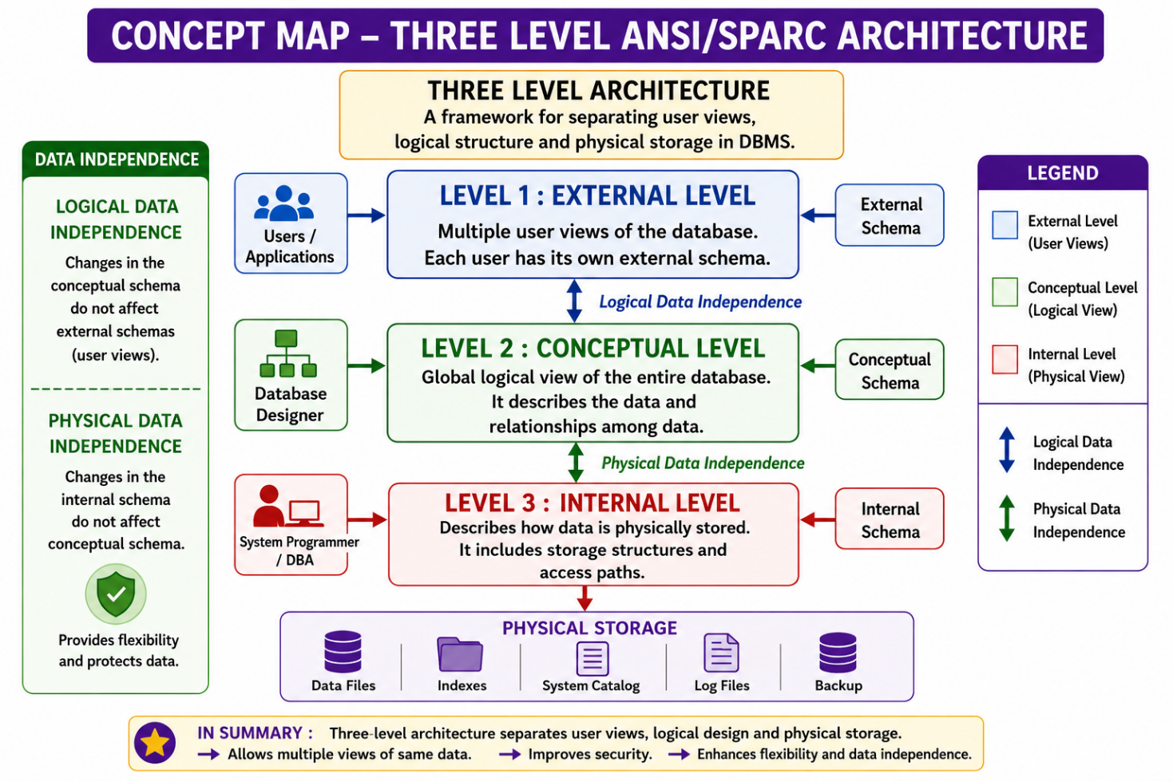

- Divides the database into External, Conceptual, and Internal levels.
- Provides logical and physical data independence for better flexibility.

3. file-based systems and database systems

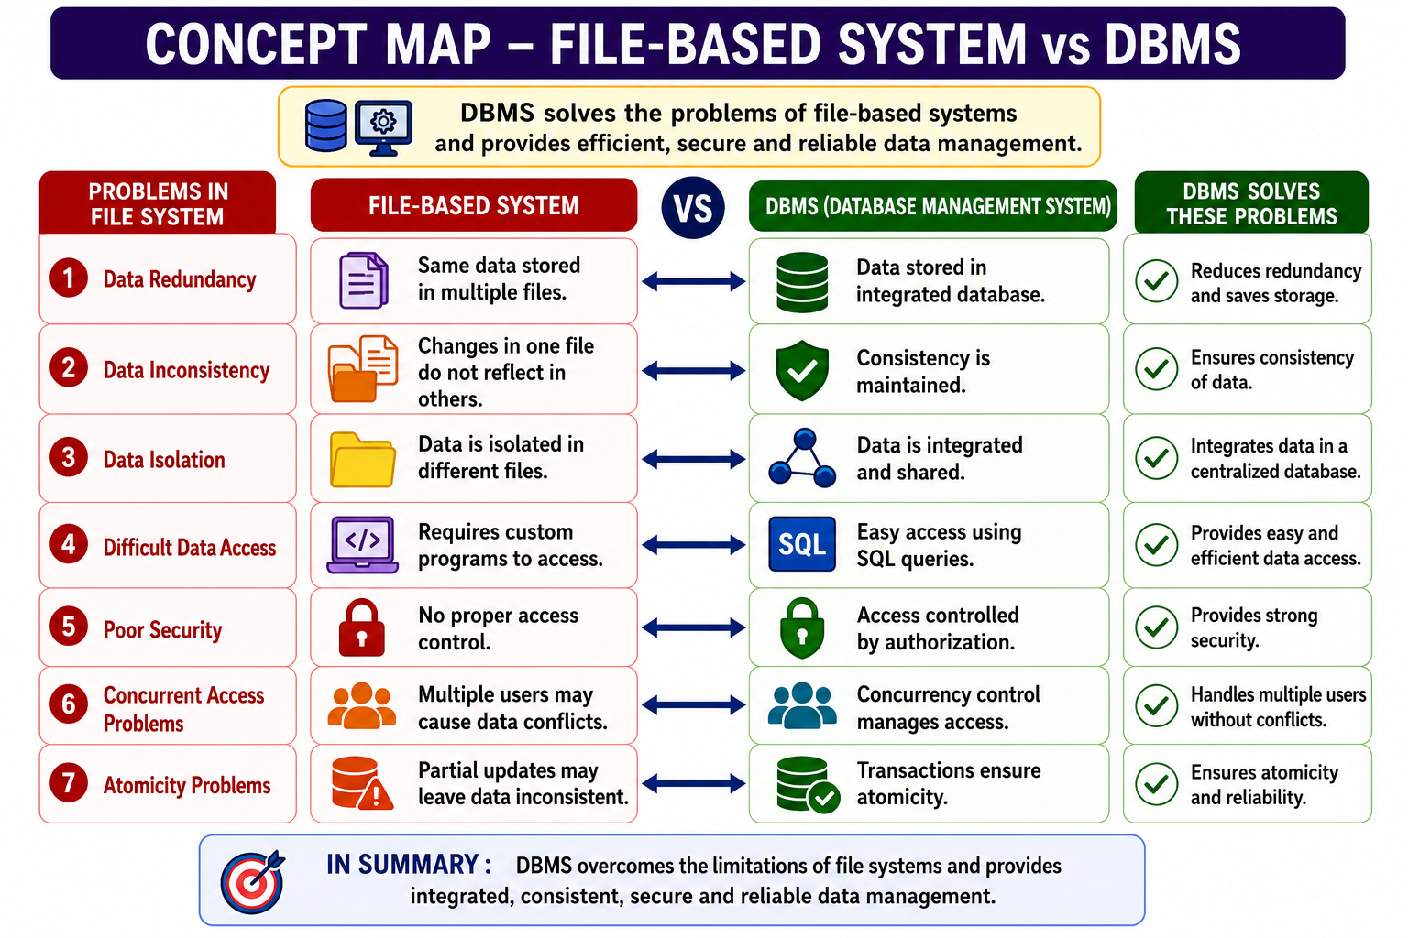

- File systems suffer from redundancy, inconsistency, and poor security.
- DBMS provides centralized storage, security, and efficient data management.

4. ER Diagram Components – Entity, Weak Entity, Attribute types, Relationship types, Participation constraints.

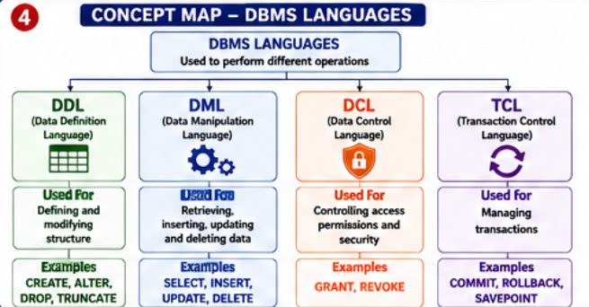

- ER diagrams represent entities, attributes, and relationships in a database.
- They help design an accurate and organized database structure.

5: Hierarchical, Network & Relational Data Models – Compare their structure, relationships, advantages, and properties.

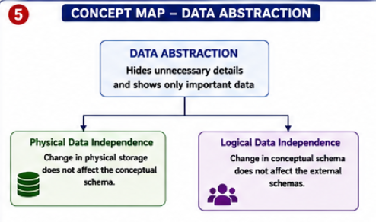

- Database models define how data is stored and connected.
- Each model is suitable for different types of applications.

6. EER Model – Show how the EER model extends the ER model using Generalization, Specialization, and Aggregation.

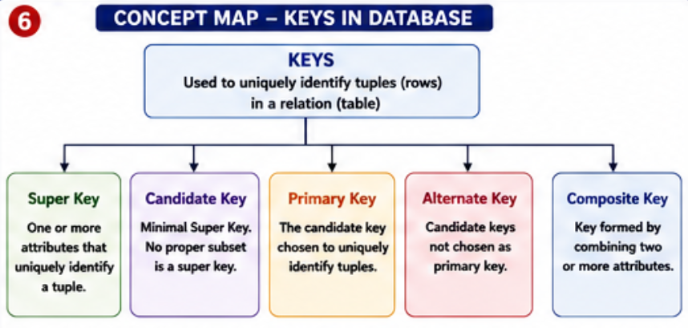

- EER extends the ER model with advanced modeling concepts.
- It includes generalization, specialization, and aggregation.

7:DBMS Software Architecture – Show the complete flow from User Request → DBMS → Query Processing → Storage → Database → Result.
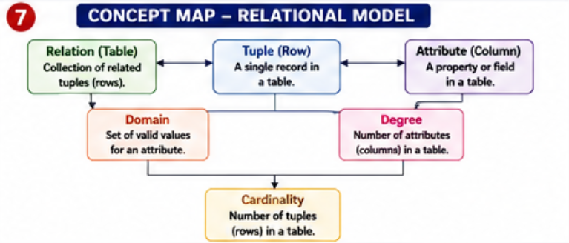

- Shows how user requests are processed to retrieve or update data.
- Includes query processing, storage management, and database access.

8: Data Models & Real-World Applications – Map each data model to suitable real-world applications and explain why.
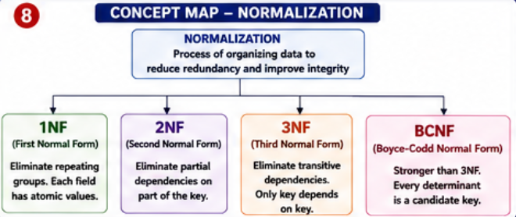

- Different data models are used for different real-world applications.
- Choosing the right model improves efficiency and performance.

9: Schema & Instance – Show their relationship with Logical and Physical Data Independence.

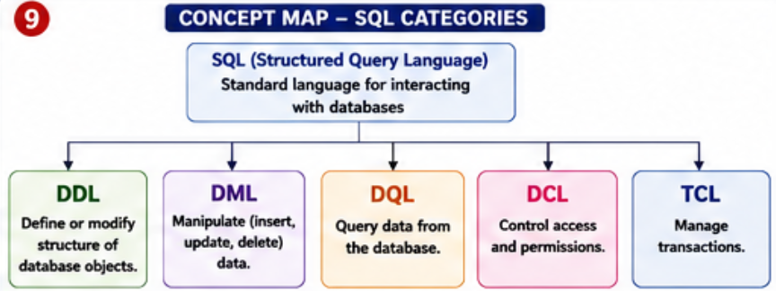

- Schema defines the database structure, while an instance represents current data.
- Data independence allows changes without affecting users or applications.

10: Roles in a DBMS Environment – DBA, End User, and Application Developer with their responsibilities and interactions.
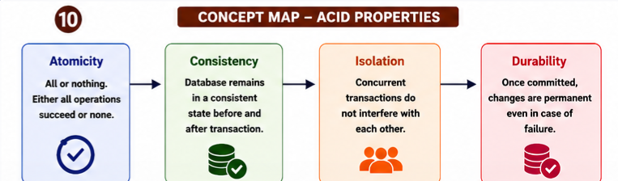

- DBA manages the database, while developers build applications.
- End users access and use the database through applications.

